Bedini monopole motor/energizer

Output (Secondary)

Input (Primary)

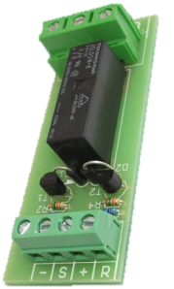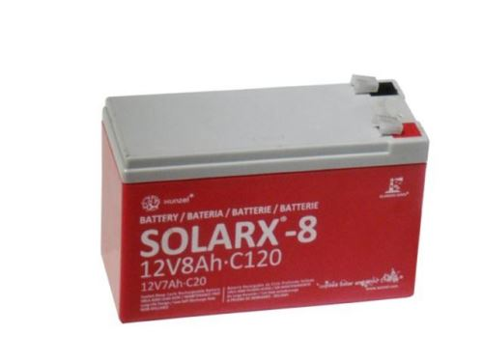

**B A C**

**B A C**

**B A C**



B1

B2

B3

B4



**B A C**

Isolation barrier

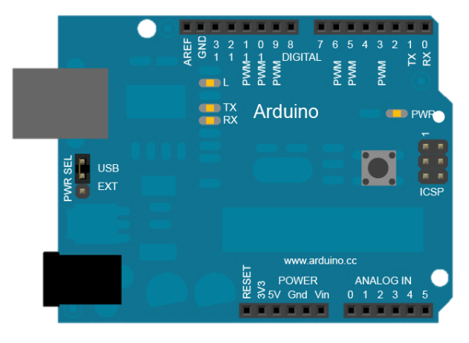

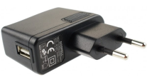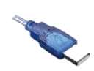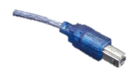

5V/1A USB Power Supply

For Arduino & Relays power

You need:

-Arduino UNO with this code:

<https://github.com/japeral/Bedinino/blob/master/sw/Bedinino_timedbatteryswitcher/Bedinino_timedbatteryswitcher.ino>

- 4x latching relay SPDT 8A 5V module.

Ebay: <http://www.ebay.es/itm/171178593872?ssPageName=STRK:MEWNX:IT&_trksid=p3984.m1497.l2649>

-Your Bedini monopole motor/energizer assembly and 4 batteries.